Digital Nurture 4.0 – Week 4
Spring Rest using Spring Boot 3

(a) Mandatory hands-on
Filename : 1. spring-rest-handson

1.Create a Spring Web Project using Maven:
Step 1:
Create a spring bot project named springlearn.Refer below details

  - Project: Maven
  - Language: Java
  - Spring Boot: 3.5.3
  - Group: com.cognizant
  - Artifact: springlearn
  - Name: springlearn
  - Package Name: com.cognizant.springlearn
  - Packaging: Jar
  - Java version: 24
Dependencies:
  - Spring Boot DevTools
  - Spring Web

Step 2:
In SpringlearnApplication.java,Add SLF4J Logger and add Add sample logging config on application.properties.

SpringlearnApplication.java:
package com.cognizant.springlearn;

import org.slf4j.Logger;
import org.slf4j.LoggerFactory;
import org.springframework.boot.SpringApplication;
import org.springframework.boot.autoconfigure.SpringBootApplication;

@SpringBootApplication
public class SpringLearnApplication {

private static final Logger LOGGER = LoggerFactory.getLogger(SpringLearnApplication.class);

public static void main(String[] args) {
LOGGER.info("START");
SpringApplication.run(SpringLearnApplication.class, args);
LOGGER.info("END");
}
}
application.properties:
logging.level.org.springframework=INFO
logging.level.com.cognizant.springlearn=DEBUG
Step 3:
Run SpringLearnApplication as a java application.

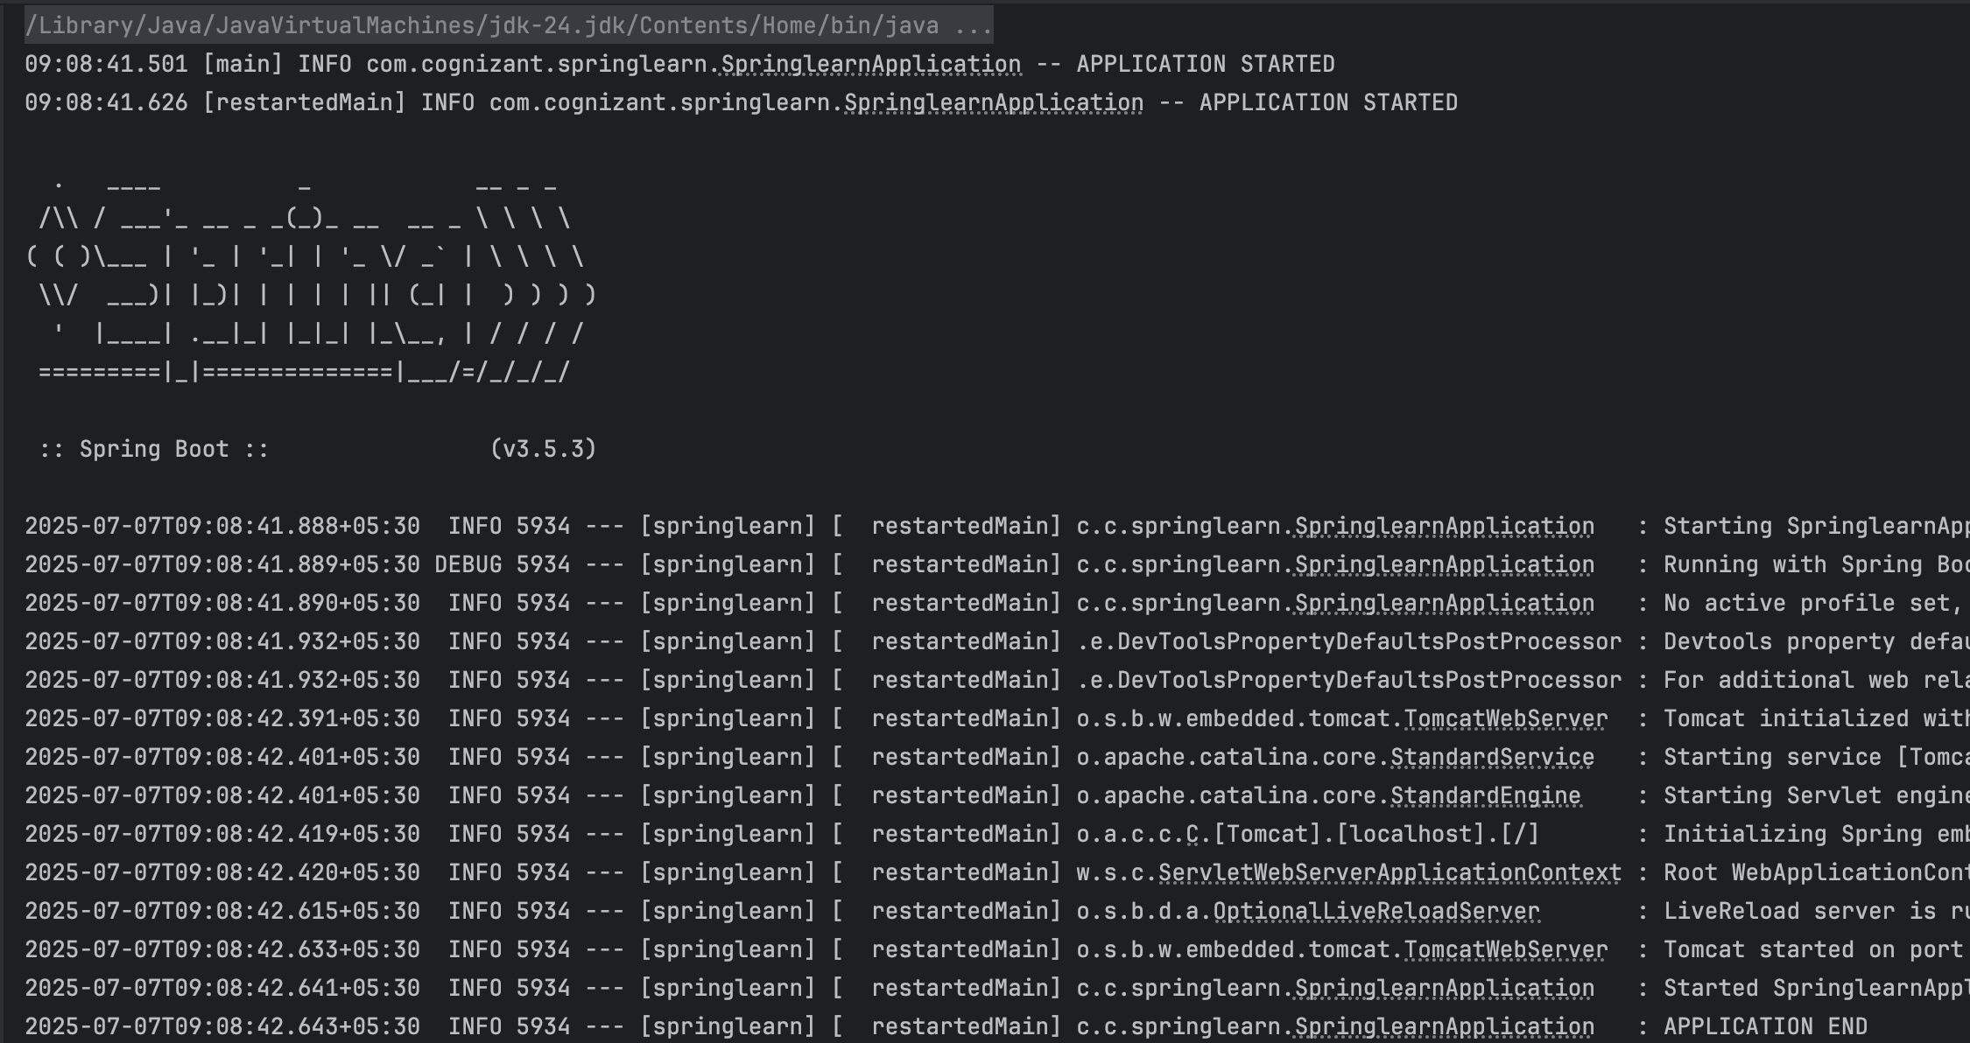

2.Spring Core – Load Country from Spring Configuration XML
Step 1:
Use the same springlearn project.Configure or Add some changes.In SpringLearnApplication.java,

package com.cognizant.springlearn;
import org.slf4j.Logger;
import org.slf4j.LoggerFactory;
import org.springframework.boot.SpringApplication;
import org.springframework.boot.autoconfigure.SpringBootApplication;
import org.springframework.context.ApplicationContext;
import org.springframework.context.support.ClassPathXmlApplicationContext;

@SpringBootApplication
public class SpringlearnApplication {
private static final Logger LOGGER = LoggerFactory.getLogger(SpringlearnApplication.class);

public static void main(String[] args) {
LOGGER.info("START");
SpringApplication.run(SpringlearnApplication.class, args);

SpringlearnApplication app = new SpringlearnApplication();
app.displayCountry();
LOGGER.info("END");
}

public void displayCountry() {
LOGGER.info("START");
ApplicationContext context = new ClassPathXmlApplicationContext("country.xml");
Country country = context.getBean("country", Country.class);
LOGGER.debug("Country : {}", country.toString());
LOGGER.info("END");
}
}

Step 2:
Create Country.java in the src/main/java/com/cognizant/springlearn directory and country.xml in the src/main/resources directory.

Country.java:
package com.cognizant.springlearn;
import org.slf4j.Logger;
import org.slf4j.LoggerFactory;

public class Country {
private static final Logger LOGGER = LoggerFactory.getLogger(Country.class);
private String code;
private String name;

public Country() {
LOGGER.debug("Inside Country Constructor");
}
public String getCode() {
LOGGER.debug("Inside getCode()");
return code;
}
public void setCode(String code) {
LOGGER.debug("Inside setCode()");
this.code = code;
}
public String getName() {
LOGGER.debug("Inside getName()");
return name;
}
public void setName(String name) {
LOGGER.debug("Inside setName()");
this.name = name;
}

@Override
public String toString() {
return "Country{" +
"code='" + code + '\'' +
", name='" + name + '\'' +
'}';
}
}
country.xml:
<?xml version="1.0" encoding="UTF-8"?>
<beans xmlns="http://www.springframework.org/schema/beans"
xmlns:xsi="http://www.w3.org/2001/XMLSchema-instance"
xsi:schemaLocation="
http://www.springframework.org/schema/beans
https://www.springframework.org/schema/beans/spring-beans.xsd">
<bean id="country" class="com.cognizant.springlearn.Country">
<property name="code" value="IN"/>
<property name="name" value="India"/>
</bean>
</beans>

Step 3:
Again run SpringLearnApplication as a java application.

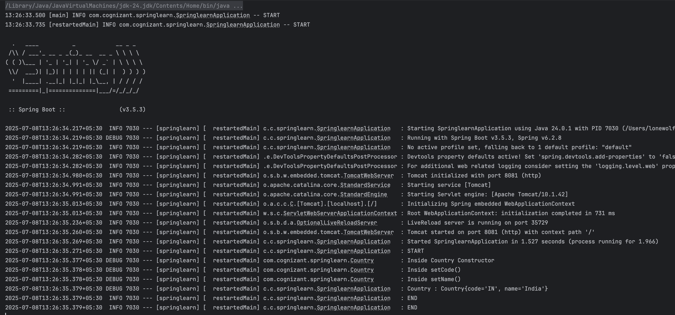

Filename : 2. spring-rest-handson

1.Hello World RESTful Web Service:
Step 1:
Use the same springlearn project.Configure some changes.In SpringLearnApplication.java,

package com.cognizant.springlearn;

import org.slf4j.Logger;
import org.slf4j.LoggerFactory;
import org.springframework.boot.SpringApplication;
import org.springframework.boot.autoconfigure.SpringBootApplication;

@SpringBootApplication
public class SpringLearnApplication {

private static final Logger LOGGER = LoggerFactory.getLogger(SpringLearnApplication.class);

public static void main(String[] args) {
LOGGER.info("START");
SpringApplication.run(SpringLearnApplication.class, args);
LOGGER.info("END");
}
}

Step 2:
Create HelloController.java in the com.cognizant.springlearn.controller directory and configure application.properties.

HelloController.java:
package com.cognizant.springlearn.controller;
import org.slf4j.Logger;
import org.slf4j.LoggerFactory;
import org.springframework.web.bind.annotation.GetMapping;
import org.springframework.web.bind.annotation.RestController;

@RestController
public class HelloController {
private static final Logger LOGGER = LoggerFactory.getLogger(HelloController.class);
@GetMapping("/hello")
public String sayHello() {
LOGGER.info("START");
String message = "Hello World!!";
LOGGER.debug("Message: {}", message);
LOGGER.info("END");
return message;
}
}

application.properties:
server.port=8083
logging.level.org.springframework=INFO
logging.level.com.cognizant.springlearn=DEBUG

Step 3:
Run SpringLearnApplication as a java application.
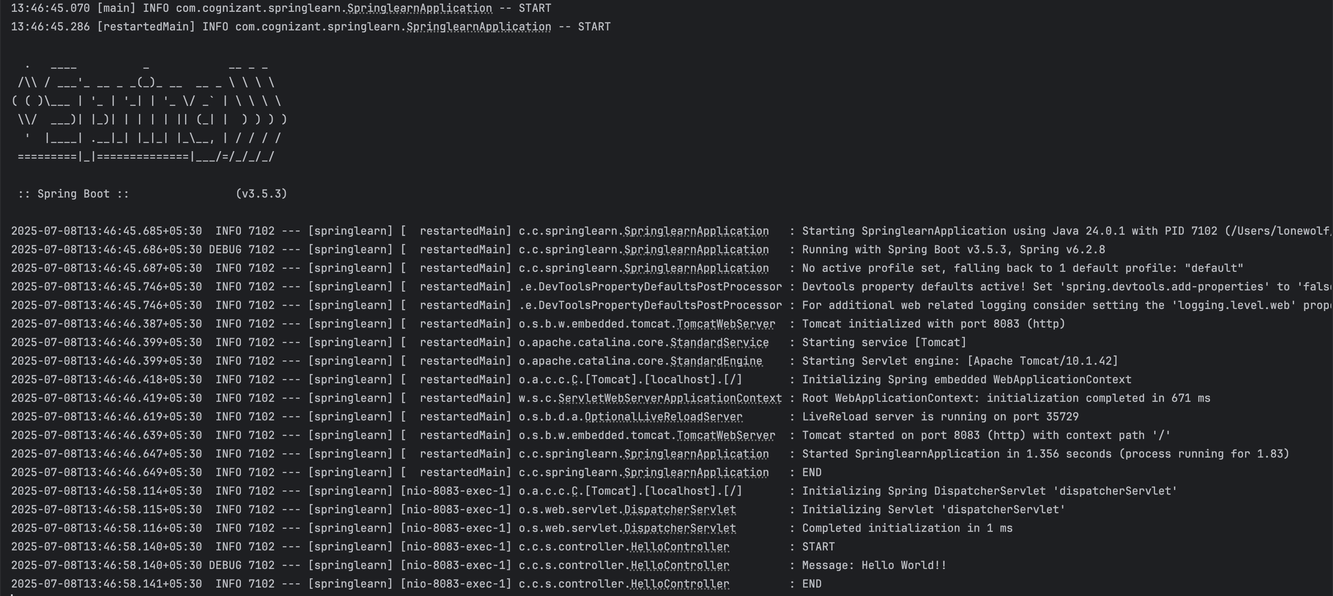

Open http://localhost:8083/hello on your browser or postman.

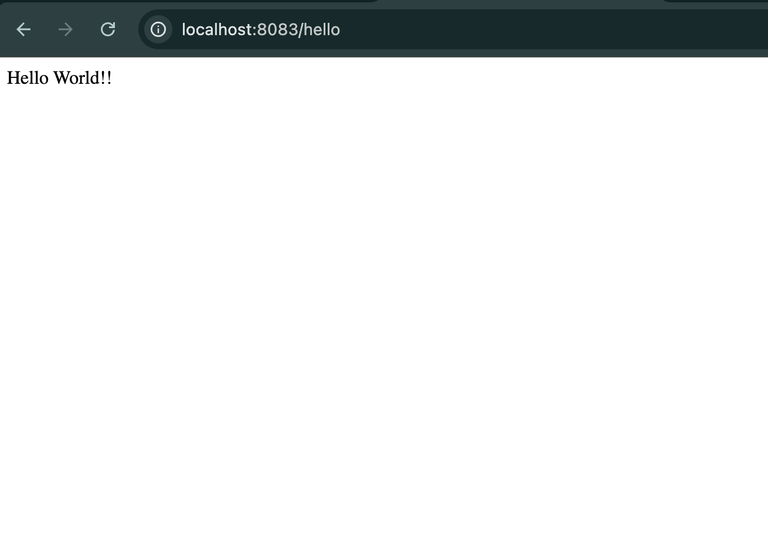

2.REST - Country Web Service:
Step 1:
Use the same springlearn project.Configure or add some changes.In SpringLearnApplication.java,

package com.cognizant.springlearn;
import org.slf4j.Logger;
import org.slf4j.LoggerFactory;
import org.springframework.boot.SpringApplication;
import org.springframework.boot.autoconfigure.SpringBootApplication;

@SpringBootApplication
public class SpringLearnApplication {

private static final Logger LOGGER = LoggerFactory.getLogger(SpringLearnApplication.class);

public static void main(String[] args) {
LOGGER.info("START");
SpringApplication.run(SpringLearnApplication.class, args);
LOGGER.info("END");
}
}

Step 2:
Create Country.java in the src/main/java/com/cognizant/springlearn directory,country.xml in the src/main/resources directory,CountryController.java in the src/main/java/com/cognizant/springlearn/controller directory and application.properties remains same.

Country.java:
package com.cognizant.springlearn;
import org.slf4j.Logger;
import org.slf4j.LoggerFactory;

public class Country {

private static final Logger LOGGER = LoggerFactory.getLogger(Country.class);

private String code;
private String name;

public Country() {
LOGGER.debug("Inside Country Constructor");
}

public String getCode() {
LOGGER.debug("Inside getCode()");
return code;
}

public void setCode(String code) {
LOGGER.debug("Inside setCode()");
this.code = code;
}

public String getName() {
LOGGER.debug("Inside getName()");
return name;
}

public void setName(String name) {
LOGGER.debug("Inside setName()");
this.name = name;
}

@Override
public String toString() {
return "Country{" +
"code='" + code + '\'' +
", name='" + name + '\'' +
'}';
}
}

country.xml:
<?xml version="1.0" encoding="UTF-8"?>

<beans xmlns="http://www.springframework.org/schema/beans"
xmlns:xsi="http://www.w3.org/2001/XMLSchema-instance"
xsi:schemaLocation="
http://www.springframework.org/schema/beans
https://www.springframework.org/schema/beans/spring-beans.xsd">

<bean id="country" class="com.cognizant.springlearn.Country">
<property name="code" value="IN"/>
<property name="name" value="India"/>
</bean>

</beans>

CountryController.java:
package com.cognizant.springlearn.controller;
import com.cognizant.springlearn.Country;
import org.slf4j.Logger;
import org.slf4j.LoggerFactory;
import org.springframework.context.ApplicationContext;
import org.springframework.context.support.ClassPathXmlApplicationContext;
import org.springframework.web.bind.annotation.RequestMapping;
import org.springframework.web.bind.annotation.RestController;

@RestController
public class CountryController {

private static final Logger LOGGER = LoggerFactory.getLogger(CountryController.class);

@RequestMapping("/country")
public Country getCountryIndia() {
LOGGER.info("START");

ApplicationContext context = new ClassPathXmlApplicationContext("country.xml");
Country country = (Country) context.getBean("country", Country.class);

LOGGER.debug("Country : {}", country);

LOGGER.info("END");
return country;
}
}
Step 3:
Run SpringLearnApplication as a java application.
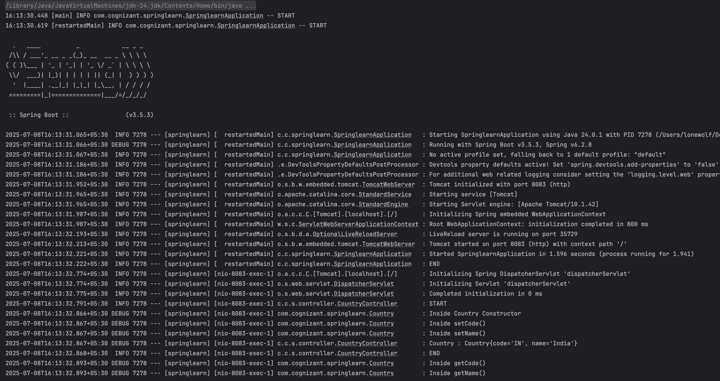

Open http://localhost:8083/country on your brower or postman.
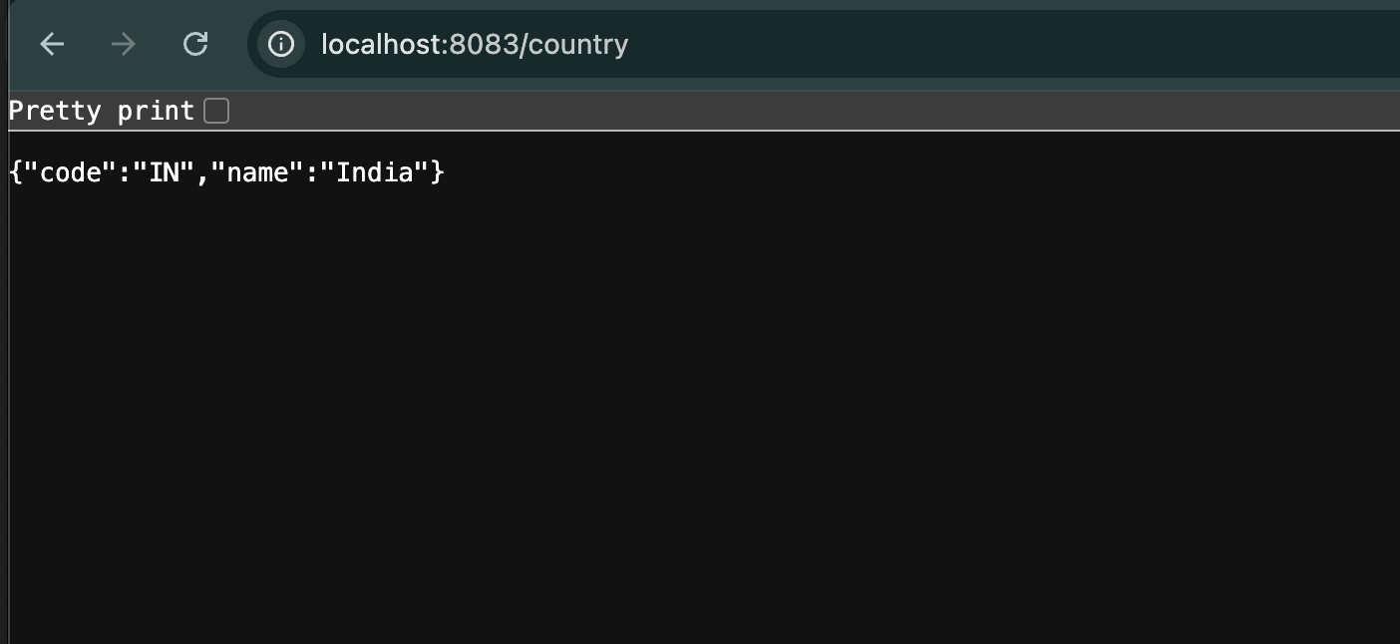

3.REST - Get country based on country code:
Step 1:
Use the same springlearn project.Configure or add some changes.In SpringLearnApplication.java,

package com.cognizant.springlearn;
import org.slf4j.Logger;
import org.slf4j.LoggerFactory;
import org.springframework.boot.SpringApplication;
import org.springframework.boot.autoconfigure.SpringBootApplication;

@SpringBootApplication
public class SpringLearnApplication {
private static final Logger LOGGER = LoggerFactory.getLogger(SpringLearnApplication.class);
public static void main(String[] args) {
LOGGER.info("START");
SpringApplication.run(SpringLearnApplication.class, args);
LOGGER.info("END");
}
}

Step 2:
Create Country.java in the src/main/java/com/cognizant/springlearn directory,country.xml in the src/main/resources directory,CountryService.java in the src/main/java/com/cognizant/springlearn/service directory,CountryNotFoundException.java in the src/main/java/com/cognizant/springlearn/service/exception directory,GlobalExceptionHandler.java in the src/main/java/com/cognizant/springlearn/service/exception,CountryController.java in the src/main/java/com/cognizant/springlearn/controller directory, and no need to chnages in the application.properties.

Country.java:
package com.cognizant.springlearn;
import org.slf4j.Logger;
import org.slf4j.LoggerFactory;
public class Country {
private static final Logger LOGGER = LoggerFactory.getLogger(Country.class);
private String code;
private String name;

public Country() {
LOGGER.debug("Inside Country Constructor");
}

public String getCode() {
LOGGER.debug("Inside getCode()");
return code;
}

public void setCode(String code) {
LOGGER.debug("Inside setCode()");
this.code = code;
}

public String getName() {
LOGGER.debug("Inside getName()");
return name;
}

public void setName(String name) {
LOGGER.debug("Inside setName()");
this.name = name;
}

@Override
public String toString() {
return "Country{" +
"code='" + code + '\'' +
", name='" + name + '\'' +
'}';
}
}

country.xml:
<?xml version="1.0" encoding="UTF-8"?>
<beans xmlns="http://www.springframework.org/schema/beans"
xmlns:xsi="http://www.w3.org/2001/XMLSchema-instance"
xsi:schemaLocation="
http://www.springframework.org/schema/beans
https://www.springframework.org/schema/beans/spring-beans.xsd">

<bean id="in" class="com.cognizant.springlearn.Country">
<property name="code" value="IN"/>
<property name="name" value="India"/>
</bean>

<bean id="us" class="com.cognizant.springlearn.Country">
<property name="code" value="US"/>
<property name="name" value="United States"/>
</bean>

<bean id="de" class="com.cognizant.springlearn.Country">
<property name="code" value="DE"/>
<property name="name" value="Germany"/>
</bean>

<bean id="jp" class="com.cognizant.springlearn.Country">
<property name="code" value="JP"/>
<property name="name" value="Japan"/>
</bean>

<bean id="countryList" class="java.util.ArrayList">
<constructor-arg>
<list>
<ref bean="in"/>
<ref bean="us"/>
<ref bean="de"/>
<ref bean="jp"/>
</list>
</constructor-arg>
</bean>
</beans>

CountryService.java:
package com.cognizant.springlearn.service;

import com.cognizant.springlearn.Country;
import com.cognizant.springlearn.service.exception.CountryNotFoundException;
import org.slf4j.Logger;
import org.slf4j.LoggerFactory;
import org.springframework.context.ApplicationContext;
import org.springframework.context.support.ClassPathXmlApplicationContext;
import org.springframework.stereotype.Service;

import java.util.List;

@Service
public class CountryService {

private static final Logger LOGGER = LoggerFactory.getLogger(CountryService.class);

public Country getCountry(String code) throws CountryNotFoundException {
LOGGER.info("START");

ApplicationContext context = new ClassPathXmlApplicationContext("country.xml");
List<Country> countryList = context.getBean("countryList", List.class);

for (Country country : countryList) {
if (country.getCode().equalsIgnoreCase(code)) {
LOGGER.debug("Country found: {}", country);
LOGGER.info("END");
return country;
}
}

LOGGER.error("Country with code {} not found", code);
throw new CountryNotFoundException("Country not found");
}
}

CountryNotFoundException.java:
package com.cognizant.springlearn.service.exception;

public class CountryNotFoundException extends Exception {

public CountryNotFoundException(String message) {
super(message);
}
}

GlobalExceptionHandler.java:
package com.cognizant.springlearn.exception;

import com.cognizant.springlearn.service.exception.CountryNotFoundException;
import org.slf4j.Logger;
import org.slf4j.LoggerFactory;
import org.springframework.http.HttpStatus;
import org.springframework.http.ResponseEntity;
import org.springframework.web.bind.annotation.ControllerAdvice;
import org.springframework.web.bind.annotation.ExceptionHandler;

import java.util.HashMap;
import java.util.Map;

@ControllerAdvice
public class GlobalExceptionHandler {

private static final Logger LOGGER = LoggerFactory.getLogger(GlobalExceptionHandler.class);

@ExceptionHandler(CountryNotFoundException.class)
public ResponseEntity<Object> handleCountryNotFoundException(CountryNotFoundException ex) {
LOGGER.error("Handling CountryNotFoundException: {}", ex.getMessage());

Map<String, Object> body = new HashMap<>();
body.put("error", "Country not found");
body.put("message", ex.getMessage());
body.put("status", HttpStatus.NOT_FOUND.value());

return new ResponseEntity<>(body, HttpStatus.NOT_FOUND);
}
}

CountryController.java:
package com.cognizant.springlearn.controller;

import com.cognizant.springlearn.Country;
import com.cognizant.springlearn.service.CountryService;
import com.cognizant.springlearn.service.exception.CountryNotFoundException;
import org.slf4j.Logger;
import org.slf4j.LoggerFactory;
import org.springframework.beans.factory.annotation.Autowired;
import org.springframework.context.ApplicationContext;
import org.springframework.context.support.ClassPathXmlApplicationContext;
import org.springframework.web.bind.annotation.*;

@RestController
public class CountryController {

private static final Logger LOGGER = LoggerFactory.getLogger(CountryController.class);

@Autowired
private CountryService countryService;

@RequestMapping("/country")
public Country getCountryIndia() {
LOGGER.info("START");

ApplicationContext context = new ClassPathXmlApplicationContext("country.xml");
Country country = (Country) context.getBean("country", Country.class);

LOGGER.debug("Country : {}", country);

LOGGER.info("END");
return country;
}

@GetMapping("/countries/{code}")
public Country getCountry(@PathVariable String code) throws CountryNotFoundException {
LOGGER.info("START");

Country country = countryService.getCountry(code);

LOGGER.debug("Country : {}", country);

LOGGER.info("END");
return country;
}
}

Step 3:
Run SpringLearnApplication as a java application.

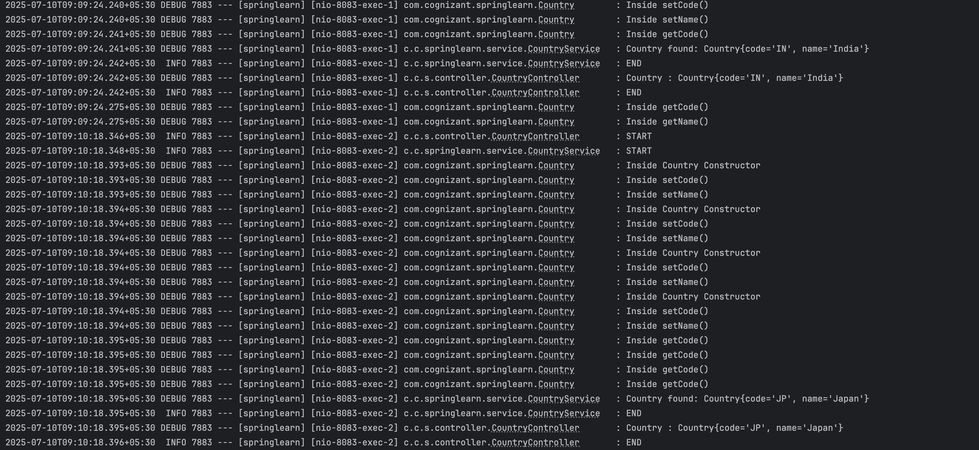

Run http://localhost:8083/countries/in,
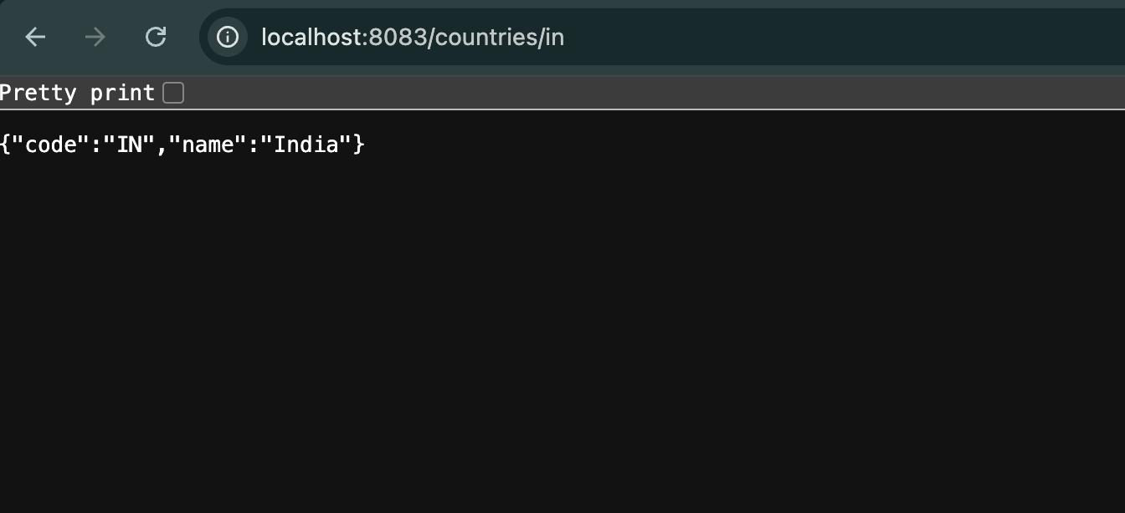

Run http://localhost:8083/countries/jp,
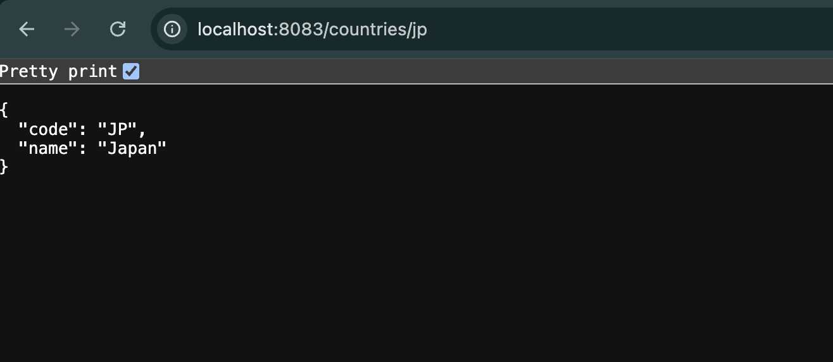

Run http://localhost:8083/countries/az,
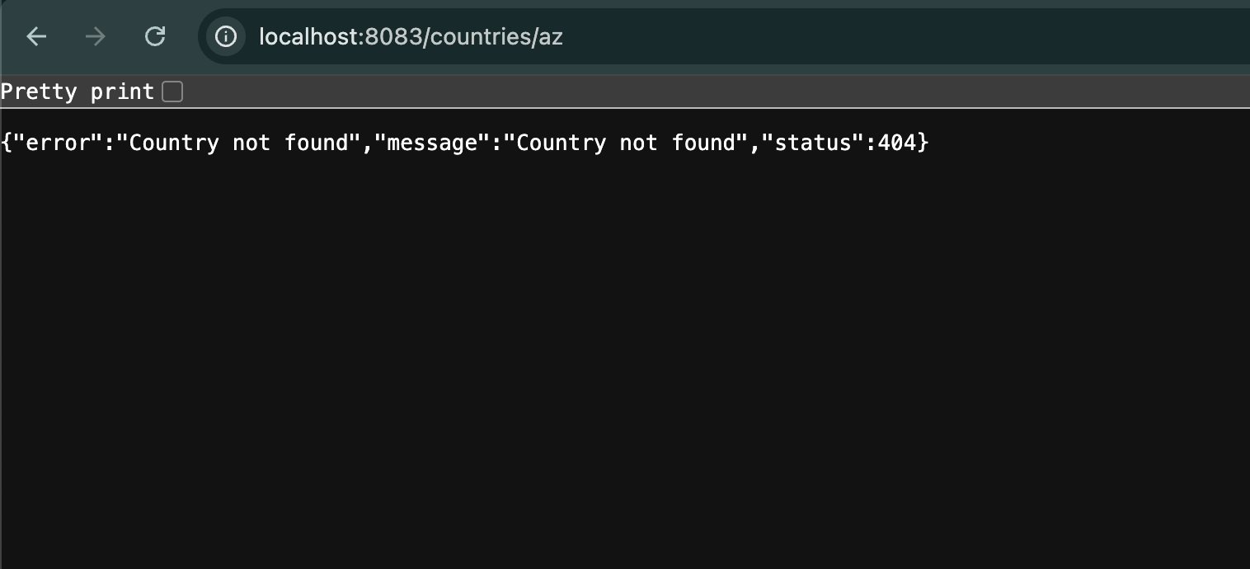

Filename : 5. JWT-handson
1.Create authentication service that returns JWT:
Step 1:
Use the same springlearn project.Configure or add some changes.In pom.xml,add addtional dependencies,

<dependency>
<groupId>org.springframework.boot</groupId>
<artifactId>spring-boot-starter-web</artifactId>
</dependency>
<dependency>
<groupId>org.springframework.boot</groupId>
<artifactId>spring-boot-starter-security</artifactId>
</dependency>
<dependency>
<groupId>io.jsonwebtoken</groupId>
<artifactId>jjwt-api</artifactId>
<version>0.11.5</version>
</dependency>
<dependency>
<groupId>io.jsonwebtoken</groupId>
<artifactId>jjwt-impl</artifactId>
<version>0.11.5</version>
<scope>runtime</scope>
</dependency>
<dependency>
<groupId>io.jsonwebtoken</groupId>
<artifactId>jjwt-jackson</artifactId>
<version>0.11.5</version>
<scope>runtime</scope>
</dependency>

SpringLearnApplication.java:
package com.cognizant.springlearn;

import org.slf4j.Logger;
import org.slf4j.LoggerFactory;
import org.springframework.boot.SpringApplication;
import org.springframework.boot.autoconfigure.SpringBootApplication;

@SpringBootApplication
public class SpringLearnApplication {

private static final Logger LOGGER = LoggerFactory.getLogger(SpringLearnApplication.class);

public static void main(String[] args) {
LOGGER.info("START");
SpringApplication.run(SpringLearnApplication.class, args);
LOGGER.info("END");
}
}

Step 2:
Create SecurityConfig.java in the src/main/java/com/cognizant/springlearn/security directory,AuthenticationController.java in the src/main/java/com/cognizant/springlearn/controller directory, and alter application.properties.

SecurityConfig.java:
package com.cognizant.springlearn.security;
import org.slf4j.Logger;
import org.slf4j.LoggerFactory;
import org.springframework.context.annotation.Bean;
import org.springframework.context.annotation.Configuration;
import org.springframework.security.config.Customizer;
import org.springframework.security.config.annotation.method.configuration.EnableMethodSecurity;
import org.springframework.security.config.annotation.web.configuration.EnableWebSecurity;
import org.springframework.security.config.annotation.web.builders.HttpSecurity;
import org.springframework.security.core.userdetails.User;
import org.springframework.security.core.userdetails.UserDetailsService;
import org.springframework.security.crypto.bcrypt.BCryptPasswordEncoder;
import org.springframework.security.crypto.password.PasswordEncoder;
import org.springframework.security.provisioning.InMemoryUserDetailsManager;
import org.springframework.security.web.SecurityFilterChain;

@Configuration
@EnableWebSecurity
@EnableMethodSecurity
public class SecurityConfig {

private static final Logger LOGGER = LoggerFactory.getLogger(SecurityConfig.class);

@Bean
public PasswordEncoder passwordEncoder() {
LOGGER.info("Creating password encoder");
return new BCryptPasswordEncoder();
}

@Bean
public UserDetailsService userDetailsService(PasswordEncoder passwordEncoder) {
LOGGER.info("Setting up in-memory users");

InMemoryUserDetailsManager manager = new InMemoryUserDetailsManager();

manager.createUser(User.withUsername("admin")
.password(passwordEncoder.encode("pwd"))
.roles("ADMIN")
.build());

manager.createUser(User.withUsername("user")
.password(passwordEncoder.encode("pwd"))
.roles("USER")
.build());

return manager;
}

@Bean
public SecurityFilterChain securityFilterChain(HttpSecurity http) throws Exception {
LOGGER.info("Configuring HTTP security");

return http
.csrf(csrf -> csrf.disable())
.authorizeHttpRequests(auth -> auth
.requestMatchers("/authenticate").hasAnyRole("ADMIN", "USER")
.anyRequest().authenticated()
)
.httpBasic(Customizer.withDefaults())
.build();
}
}

AuthenticationController.java:
package com.cognizant.springlearn.controller;
import io.jsonwebtoken.Jwts;
import io.jsonwebtoken.security.Keys;
import org.slf4j.Logger;
import org.slf4j.LoggerFactory;
import org.springframework.web.bind.annotation.GetMapping;
import org.springframework.web.bind.annotation.RequestHeader;
import org.springframework.web.bind.annotation.RestController;

import java.security.Key;
import java.util.Base64;
import java.util.Date;
import java.util.HashMap;
import java.util.Map;

@RestController
public class AuthenticationController {

private static final Logger LOGGER = LoggerFactory.getLogger(AuthenticationController.class);

private static final String SECRET_KEY = "12345678901234567890123456789012";

@GetMapping("/authenticate")
public Map<String, String> authenticate(@RequestHeader("Authorization") String authHeader) {
LOGGER.info("START");
LOGGER.debug("Authorization Header: {}", authHeader);

String user = extractUser(authHeader);
String token = generateJwt(user);

Map<String, String> response = new HashMap<>();
response.put("token", token);

LOGGER.info("END");
return response;
}

private String extractUser(String authHeader) {
LOGGER.info("Start extractUser()");
String encoded = authHeader.substring(6);
byte[] decodedBytes = Base64.getDecoder().decode(encoded);
String decodedString = new String(decodedBytes);
String user = decodedString.split(":")[0];

LOGGER.debug("Decoded User: {}", user);
return user;
}

private String generateJwt(String user) {
LOGGER.info("Start generateJwt()");

Key key = Keys.hmacShaKeyFor(SECRET_KEY.getBytes());

String token = Jwts.builder()
.setSubject(user)
.setIssuedAt(new Date())
.setExpiration(new Date(System.currentTimeMillis() + 20 * 60 * 1000))
.signWith(key)
.compact();

LOGGER.debug("Generated Token: {}", token);
return token;
}
}

application.properties:
server.port=8085
logging.level.org.springframework=INFO
logging.level.com.cognizant.springlearn=DEBUG

Step 3:
Run SpringLearnApplication as a java application.
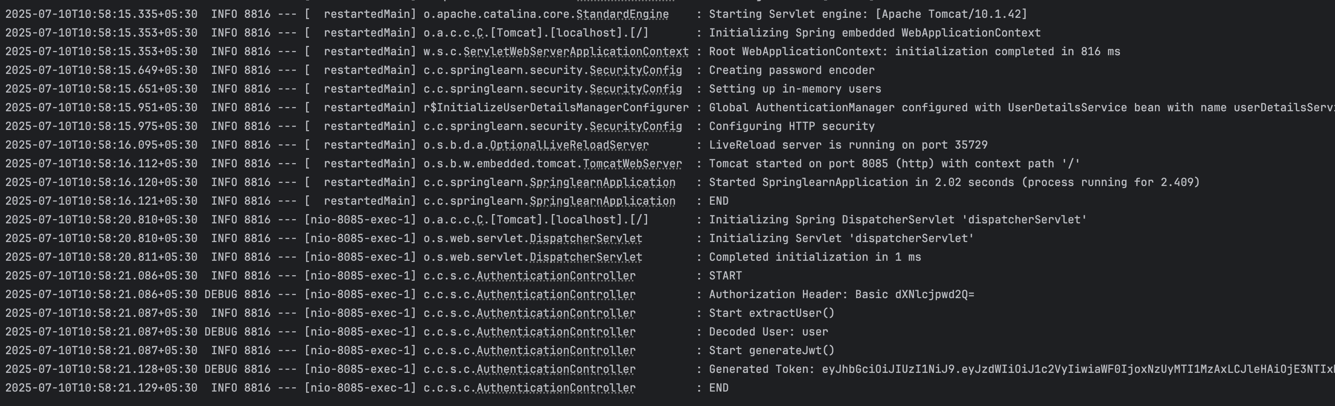

Run curl -u user:pwd http://localhost:8085/authenticate in your terminal.
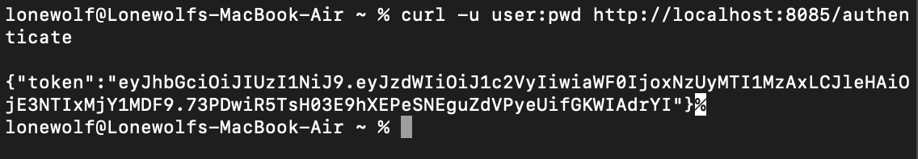

Now copy that token and paste it on online JWT Decoder to verify.
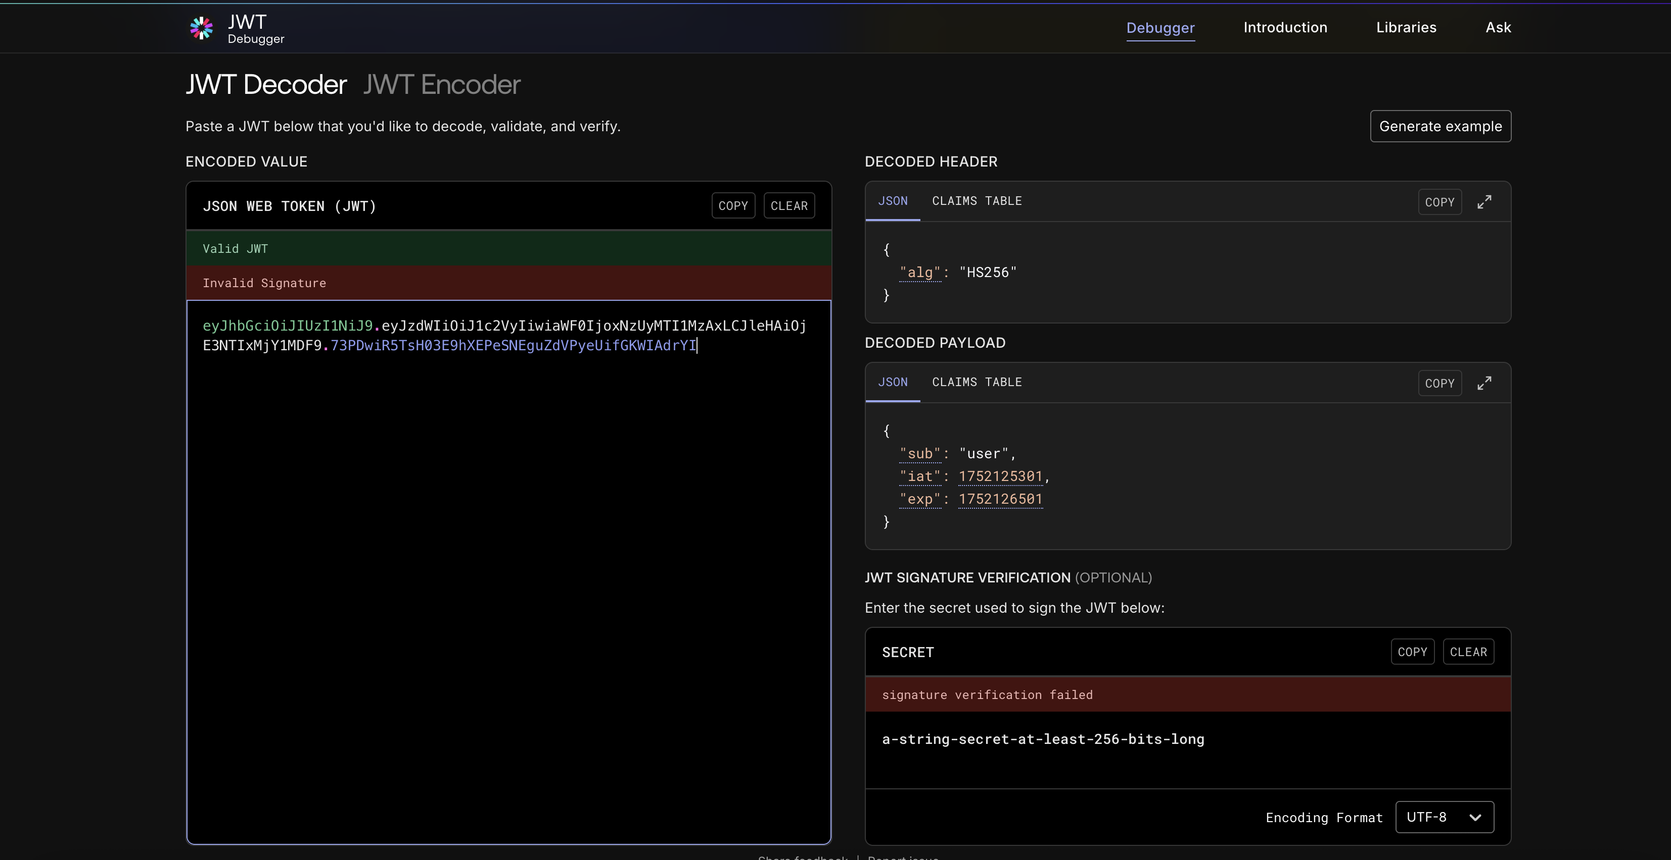

(b) Additional important hands-on
Filename : 3. spring-rest-handson
Step 1:
Configure spring.io based on beloe details,
Field | Value
Project | Maven
Language | Java
Spring Boot | 3.5.3
Group | com.example
Artifact | springresthandson
Name | springresthandson
Description | Spring Boot REST Handson Project
Package Name | com.example.springresthandson
Packaging | Jar
Java Version | 24
Dependencies | - Spring Web -

Step 2:
Configure SpringRestHandsonApplication.java and pom.xml:

SpringRestHandsonApplication.java:
package com.example.springresthandson;
import org.springframework.boot.SpringApplication;
import org.springframework.boot.autoconfigure.SpringBootApplication;

@SpringBootApplication
public class SpringRestHandsonApplication {

public static void main(String[] args) {
SpringApplication.run(SpringRestHandsonApplication.class, args);
}
}

Pom.xml:
<?xml version="1.0" encoding="UTF-8"?>
<project xmlns="http://maven.apache.org/POM/4.0.0"
xmlns:xsi="http://www.w3.org/2001/XMLSchema-instance"
xsi:schemaLocation="http://maven.apache.org/POM/4.0.0 https://maven.apache.org/xsd/maven-4.0.0.xsd">

<modelVersion>4.0.0</modelVersion>

<parent>
<groupId>org.springframework.boot</groupId>
<artifactId>spring-boot-starter-parent</artifactId>
<version>3.5.3</version>
<relativePath/> <!-- lookup parent from repository -->
</parent>

<groupId>com.example</groupId>
<artifactId>spring-rest-handson</artifactId>
<version>0.0.1-SNAPSHOT</version>
<name>spring-rest-handson</name>
<description>Spring Boot REST Handson Project</description>

<properties>
<java.version>24</java.version>
</properties>

<dependencies>
<dependency>
<groupId>org.springframework.boot</groupId>
<artifactId>spring-boot-starter-web</artifactId>
</dependency>

<dependency>
<groupId>org.springframework</groupId>
<artifactId>spring-context</artifactId>
</dependency>

<dependency>
<groupId>org.springframework.boot</groupId>
<artifactId>spring-boot-starter-test</artifactId>
<scope>test</scope>
</dependency>
</dependencies>

<build>
<plugins>
<plugin>
<groupId>org.springframework.boot</groupId>
<artifactId>spring-boot-maven-plugin</artifactId>
</plugin>
</plugins>
</build>

</project>

Step 2:
Create EmployeeController.java in the controller package,EmployeeDao.java in the dao package,EmployeeService.java in the service package,employee.xml in the resource directory,Skill.java and Employee.java in the model package.

EmployeeController.java:
package com.example.springresthandson.controller;
import com.example.springresthandson.model.Employee;
import com.example.springresthandson.service.EmployeeService;
import org.springframework.web.bind.annotation.GetMapping;
import org.springframework.web.bind.annotation.RequestMapping;
import org.springframework.web.bind.annotation.RestController;

@RestController
@RequestMapping("/employee")
public class EmployeeController {

private final EmployeeService employeeService;

public EmployeeController(EmployeeService employeeService) {
this.employeeService = employeeService;
}

@GetMapping
public Employee getEmployee() {
return employeeService.getEmployee();
}
}

EmployeeDao.java:
package com.example.springresthandson.dao;
import com.example.springresthandson.model.Employee;
import org.springframework.context.ApplicationContext;
import org.springframework.context.support.ClassPathXmlApplicationContext;
import org.springframework.stereotype.Repository;

@Repository
public class EmployeeDao {
private final Employee employee;
public EmployeeDao() {
ApplicationContext context = new ClassPathXmlApplicationContext("employee.xml");
this.employee = (Employee) context.getBean("employee");
}

public Employee getEmployee() {
return employee;
}
}

employee.xml:
<?xml version="1.0" encoding="UTF-8"?>
<beans xmlns="http://www.springframework.org/schema/beans"
xmlns:xsi="http://www.w3.org/2001/XMLSchema-instance"
xsi:schemaLocation="
http://www.springframework.org/schema/beans
https://www.springframework.org/schema/beans/spring-beans.xsd">

<bean id="skillJava" class="com.example.springresthandson.model.Skill">
<property name="id" value="1"/>
<property name="name" value="Java"/>
</bean>

<bean id="skillSpring" class="com.example.springresthandson.model.Skill">
<property name="id" value="2"/>
<property name="name" value="Spring"/>
</bean>

<bean id="employee" class="com.example.springresthandson.model.Employee">
<property name="id" value="101"/>
<property name="name" value="John Doe"/>
<property name="salary" value="50000"/>
<property name="skills">
<list>
<ref bean="skillJava"/>
<ref bean="skillSpring"/>
</list>
</property>
</bean>
</beans>

EmployeeService.java:
package com.example.springresthandson.service;
import com.example.springresthandson.model.Employee;
import com.example.springresthandson.dao.EmployeeDao;
import org.springframework.stereotype.Service;

@Service
public class EmployeeService {

private final EmployeeDao employeeDao;

public EmployeeService(EmployeeDao employeeDao) {
this.employeeDao = employeeDao;
}

public Employee getEmployee() {
return employeeDao.getEmployee();
}
}

Skill.java:
package com.example.springresthandson.model;
import java.io.Serializable;

public class Skill implements Serializable {

private String id;
private String name;

public Skill() {
}

public Skill(String id, String name) {
this.id = id;
this.name = name;
}

public String getId() {
return id;
}

public void setId(String id) {
this.id = id;
}

public String getName() {
return name;
}

public void setName(String name) {
this.name = name;
}

@Override
public String toString() {
return "Skill{" +
"id='" + id + '\'' +
", name='" + name + '\'' +
'}';
}
}
Employee.java:
package com.example.springresthandson.model;

import java.io.Serializable;
import java.util.List;

public class Employee implements Serializable {

private String id;
private String name;
private double salary;
private List<Skill> skills;

public Employee() {
}

public Employee(String id, String name, double salary, List<Skill> skills) {
this.id = id;
this.name = name;
this.salary = salary;
this.skills = skills;
}
public String getId() {
return id;
}

public void setId(String id) {
this.id = id;
}

public String getName() {
return name;
}

public void setName(String name) {
this.name = name;
}

public double getSalary() {
return salary;
}
public void setSalary(double salary) {
this.salary = salary;
}
public List<Skill> getSkills() {
return skills;
}

public void setSkills(List<Skill> skills) {
this.skills = skills;
}
@Override
public String toString() {
return "Employee{" +
"id='" + id + '\'' +
", name='" + name + '\'' +
", salary=" + salary +
", skills=" + skills +
'}';
}
}

Step 3:
Run SpringRestHandsonApllication.java as a java application.And run http://localhost:8080/employee on your browser.

